Project Design Phase-II Technology Stack (Architecture & Stack)

Date | 15 February 2026
Team ID | LTVIP2026TMIDS24941
Project Name | ToyCraft Tales: Tableau's Vision into Toy  Manufacturer Data
Maximum Marks | 4 Marks

Technical Architecture:
The Deliverable shall include the architectural diagram as below and the information as per the table1 & table 2
Example: Order processing during pandemics for offline mode
Reference: https://developer.ibm.com/patterns/ai-powered-backend-system-for-order-processing-during-pandemics/

Guidelines:
Include all the processes (As an application logic / Technology Block)
Provide infrastructural demarcation (Local / Cloud) Indicate external interfaces (third party API’s etc.) Indicate Data Storage components / services Indicate interface to machine learning models (if applicable)

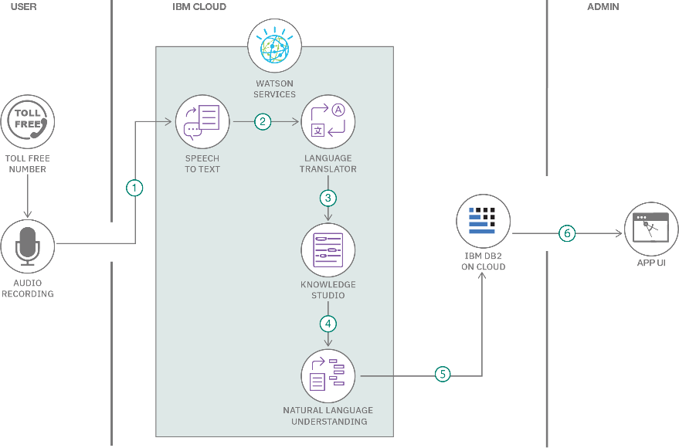
Table-1 : Components & Technologies:

S.No | Component | Description | Technology
1. | Dashboard Interface | Visual interface to explore toy sales trends, regional stats, seasonal patterns | Tableau Public/Desktop
2. | Data Storage | Stores toy manufacturing and sales data for analysis | Excel / Google Sheets / CSV
3. | Data Processing | Prepares and cleans datasets before visualization | Tableau Prep / Excel
4. | Survey Collection | Captures user preferences or toy feedback | Google Forms / Typeform
5. | Survey Visualization | Displays user feedback as charts on the dashboard | Tableau Embedded Charts
6. | User Access Control | Allows admin to manage user login, access, and dash usage | Manual / Google Auth board
7. | Data Export Function | Lets users download charts and graphs for reports or analysis | Tableau Export (PDF/PNG)
8. | Notifications/Follow-up | Sends updates to users about new dashboards or toy trends | Email (via Gmail integration / Mailchimp)

9. | Platform Hosting | Hosts the dashboard or project for online access | Google Drive / Tableau Public / GitHub Pages

Table-2: Application Characteristics:

S.No | Characteristics | Description | Technology
1. | User-Friendliness | Simple and intuitive dashboard interface for students, parents, and analysts | Tableau (filters, tooltips, charts)
2. | Data Visualization | Clear graphical representation of toy trends by region, season, and type | Tableau Public/Desktop
3. | Data Import & Refresh | Ability to upload, clean, and update datasets | Excel / Tableau Prep
4. | Accessibility | Accessible on web and mobile for easy interaction | Tableau Public, Web Browser
5. | Survey Integration | Collects and visualizes user preferences through em surveys | Google Forms + Tableau bedded
6. | Security | Ensures secure access through authentication methods (email/Gmail) | Google Auth / Login System
7. | Exportability | Allows users to download insights for offline use | PDF/PNG Export (Tableau)
8. | Scalability | Can be expanded to include more regions, years, or toy categories | Tableau, Modular Dataset Design

References:
https://c4model.com/
https://developer.ibm.com/patterns/online-order-processing-system-during-pandemic/ https://www.ibm.com/cloud/architecture
https://aws.amazon.com/architecture

https://medium.com/the-internal-startup/how-to-draw-useful-technical-architecture-diagrams-2d20c9fda90d

